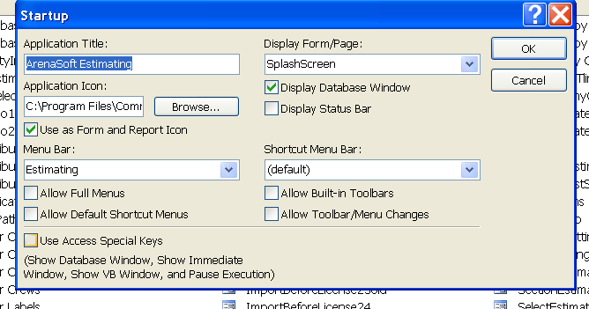

Application Icon: C:\Program Files\Common Files\Asoft.ico

